

TITEL
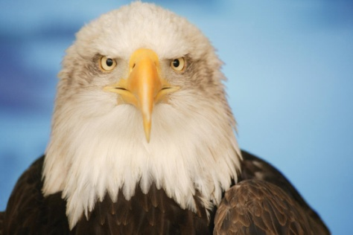
Ctrl+Click to enter the story


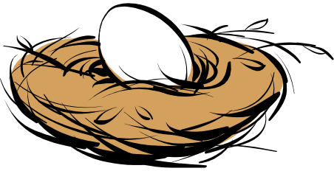
Welcome to the eagle’s nest. NEST

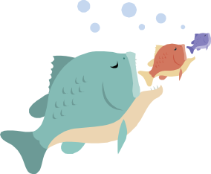
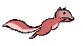
Hunter for food in the forest or look for fish in the water

DIVE FOR FOOD
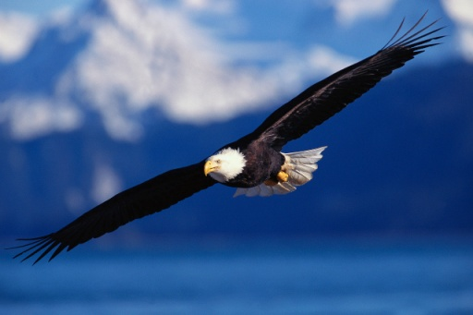

Go for the kill or Go back to the nest

FOREST FOR FOOD
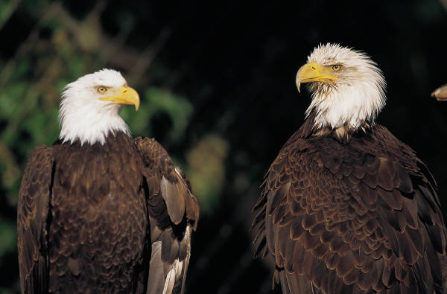

Go for the kill or Go back to the nest

BEAR
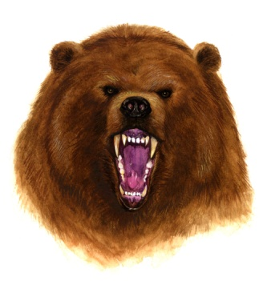
Oh on you got eaten by a bear while you were on a branch looking for a small furry animal

Ctrl+Click to play again

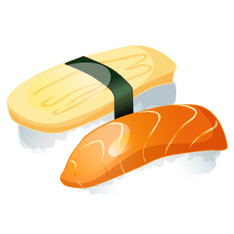
KILLED
You dove for the kill and got a fresh new fish right in your own beck. You had a big dinner.

Oh on a storm is coming straight to your nest.

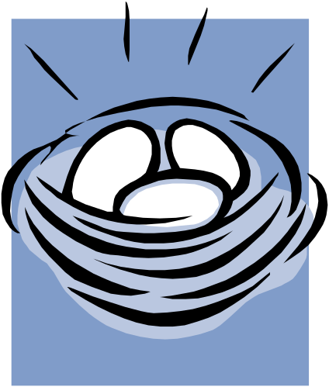
Stay in your same home or Find a safe new nest

You stay in your nest and got wiped to the ground with both cracked wings.
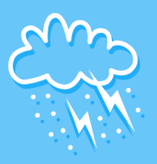

STAY

Ctrl+Click to play again

NEW
You happy dodged the storm and made a whole new nest.

Scroll
Down

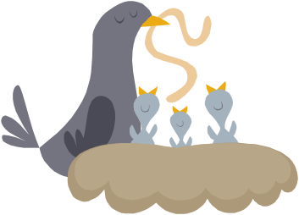
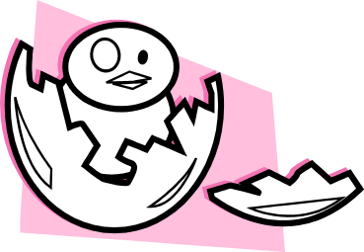
Feed your younglings or let them starve

CHICKS

You fed you little chicks and they are full and ready to fly.

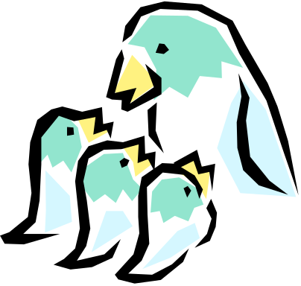
Let to chicks jump off the nest or let them fly on there mothers back
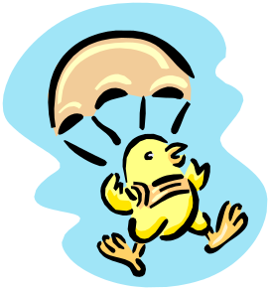
STARVE
You let your only chicks die in front of you.
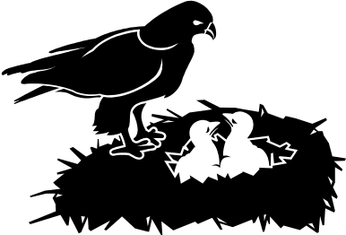

Ctrl+Click to play again

JUMP
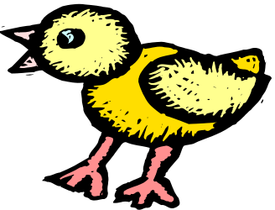
The chicks jumped off the nest and started to flap their wings. Then fell to the ground and now there are dead.

Ctrl+Click to play again

FLY
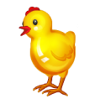
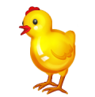
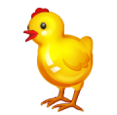
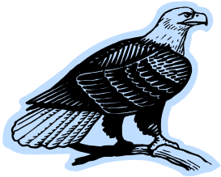
All the chicks hopped on the mother’s back and went flying around the lake.
This is awesome
Cool!
Yah!

Yah you win! The chicks and mother both land in the nest safety. Lived happily ever after.

Ctrl+Click to play again

